TOPIC: SMART WASTE MANGEMENT SYSTEM FOR MERTROPOLITAN CITIES

TEAM ID; PNT2022TMID08297

Running on IBM Cloud

Node-RED is available on the IBM Cloud platform as one of the [Starter Kits applications](https://nodered.org/docs/getting-started/ibmcloud#starter-kit-application) in the catalog.

We also provide a ‘[Deploy To IBM Cloud](https://nodered.org/docs/getting-started/ibmcloud#deploy-to-ibm-cloud)’ enabled repository.

Starter Kit application

1. Log in or sign-up for an account at [cloud.ibm.com](https://cloud.ibm.com/)
2. Navigate to the catalog and [search for ‘Node-RED’](https://cloud.ibm.com/catalog?search=node-red). This will present you with the **Node-RED Starter**. This gives you a Node-RED instance running as a Cloud Foundry application. It also provides a Cloudant database instance and a collection of nodes that make it easy to access various IBM Cloud services.
3. Click the starter application you want to use, give it a name and click create.

A couple of minutes later, you’ll be able to access your instance of Node-RED at https://<yourAppName>.mybluemix.net

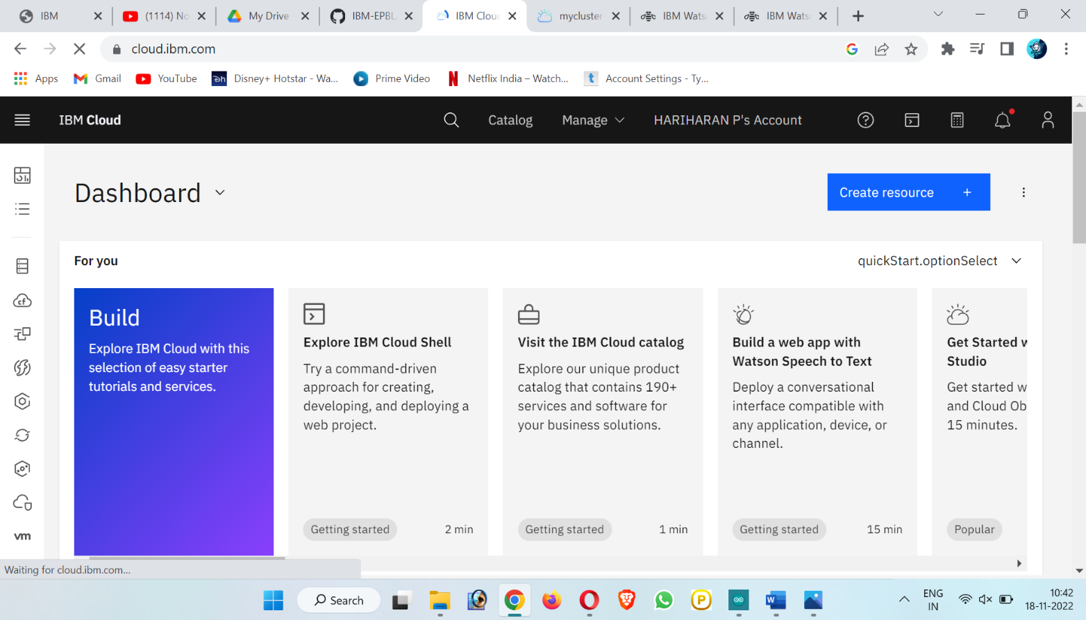

#### **Customising your Node-RED application**

To start customising your instance of Node-RED, you can either download the application locally or you can enable the Continuous Delivery integration option via your application’s IBM Cloud dashboard page. That will create a git repository on either GitHub or IBM DevOps services, from where you can customize your Node-RED, save the changes and automatically update the application in IBM Cloud.

##### **Securing the editor**

When you first ran the Node-RED instance you were presented with some options to secure the editor. To change those options, you can set some environment variables from either the IBM Cloud console or the cf command-line

1. In the IBM Cloud dashboard, select the ‘Environment Variables’ page for your application
2. Add the required user-defined variables:
   * NODE_RED_USERNAME - the username to secure the editor with
   * NODE_RED_PASSWORD - the password to secure the editor with
   * NODE_RED_GUEST_ACCESS - set to true to allow anonymous users to have read-only access to the editor
3. Click Save.

